**Investigation:**

**Heat of combustion of alcohols**

**Data Analysis: (to be completed prior to class)**

For each alcohol, calculate:

1. The heat gained by the water (in kJ)
2. The moles of alcohol consumed (in mol)
3. The heat released per mole of alcohol (in kJ/mol)

When calculating the heat gained by the water, use the formula **Q = m c ΔT**.

In this equation:

* Q is the heat energy (in J)
* m is the mass of water (in g)
* c is the specific heat of water (c = 4.18 J K-1 g-1)
* ΔT is the change in temperature of the water (in °C or K)

**Methanol (CH3OH)** (3 marks)

**Ethanol (CH3CH2OH)** (3 marks)

**Propan-1-ol (CH3CH2CH2OH)** (3 marks)

**Butan-1-ol (CH3CH2CH2CH2OH)** (3 marks)

The following table shows values for the combustion of alcohols that have been reported in scientific reports.

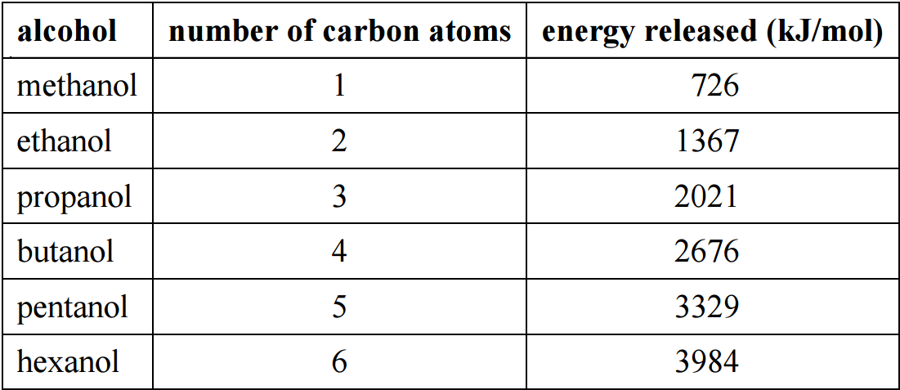

Compare your values to those which have been reported. (1 mark)

**Investigation:**

**Heat of combustion of alcohols**

**To be completed in class**

**Variables:**

1. What was the independent variable? (1 mark)

1. What was the dependent variable? (1 mark)

1. List three variables that were controlled and briefly state *how* they were controlled. (3 marks)

**Calculations:**

A student heated 150ml of water using pent-1-ol, which has an enthalpy of combustion of 3330 kJ mol-1. What temperature change would be expected if the student heated 35.0 g of pent-1-ol? (4 marks)

**Results table:**

Draw a neat results table showing the average heat released per mole of alcohol for each of the four alcohols. Include a column for the length of the carbon chain (1-4). (3 marks)

**Graph:**

Draw a graph showing the relationship between carbon chain length and heat released. Include title, axes labels and a suitable scale. (6 marks)

|  |  |  |  |  |  |  |  |  |  |  |  |  |  |  |  |  |  |  |  |  |
| --- | --- | --- | --- | --- | --- | --- | --- | --- | --- | --- | --- | --- | --- | --- | --- | --- | --- | --- | --- | --- |
|  |  |  |  |  |  |  |  |  |  |  |  |  |  |  |  |  |  |  |  |  |
|  |  |  |  |  |  |  |  |  |  |  |  |  |  |  |  |  |  |  |  |  |
|  |  |  |  |  |  |  |  |  |  |  |  |  |  |  |  |  |  |  |  |  |
|  |  |  |  |  |  |  |  |  |  |  |  |  |  |  |  |  |  |  |  |  |
|  |  |  |  |  |  |  |  |  |  |  |  |  |  |  |  |  |  |  |  |  |
|  |  |  |  |  |  |  |  |  |  |  |  |  |  |  |  |  |  |  |  |  |
|  |  |  |  |  |  |  |  |  |  |  |  |  |  |  |  |  |  |  |  |  |
|  |  |  |  |  |  |  |  |  |  |  |  |  |  |  |  |  |  |  |  |  |
|  |  |  |  |  |  |  |  |  |  |  |  |  |  |  |  |  |  |  |  |  |
|  |  |  |  |  |  |  |  |  |  |  |  |  |  |  |  |  |  |  |  |  |
|  |  |  |  |  |  |  |  |  |  |  |  |  |  |  |  |  |  |  |  |  |
|  |  |  |  |  |  |  |  |  |  |  |  |  |  |  |  |  |  |  |  |  |
|  |  |  |  |  |  |  |  |  |  |  |  |  |  |  |  |  |  |  |  |  |
|  |  |  |  |  |  |  |  |  |  |  |  |  |  |  |  |  |  |  |  |  |
|  |  |  |  |  |  |  |  |  |  |  |  |  |  |  |  |  |  |  |  |  |
|  |  |  |  |  |  |  |  |  |  |  |  |  |  |  |  |  |  |  |  |  |
|  |  |  |  |  |  |  |  |  |  |  |  |  |  |  |  |  |  |  |  |  |
|  |  |  |  |  |  |  |  |  |  |  |  |  |  |  |  |  |  |  |  |  |

**Discussion questions:**

1. Focusing on methanol in particular…
2. Write a balanced chemical equation for the combustion of **1 mole** of methanol. Give ΔH, which represents the energy released or absorbed per mole of methanol. Be sure to include the correct sign with your ΔH values. (2 marks)  
     
   Note: You may need to express the moles of O2(g) as an improper fraction. e.g. O2(g)

1. Compare the relative enthalpies of the products and the reactants (1 mark)

1. Explain, in terms of bond breaking and bond forming, why energy was released when you burnt the methanol. (2 marks)

1. Draw a fully labelled enthalpy diagram for the combustion of methanol. (5 marks)

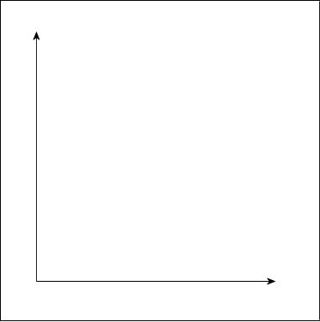

**Parts b) to d) refer to experimental ‘errors’. See also: Nelson Chemistry pg. 411.**

1. Identify one major source of error which may have contributed to your answers being different to the ones shown above. Briefly explain how the error impacted your results. (2 marks)

1. Is the error listed above a random error or a systematic error. Explain your reasoning.

(2 marks)

1. Suggest an improvement that could be made that could reduce the effect of this error in the future. Explain how your modification would improve the validity of your results. (2 marks)